Level 3 Practice: Pivot Tables & Dashboard Project Questions

Part A — Pivot Table Basics

Q1. Machine Count Analysis
Create a Pivot Table to find:
- Total number of machines
- Machine count by Department
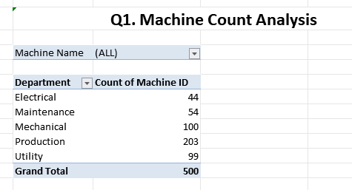

Q2. Production Analysis
Create a Pivot Table showing:
- Total Production by Department
- Average Production by Machine
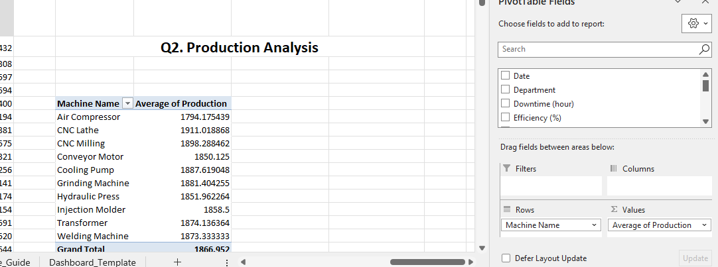

Q3. Downtime Analysis
Create a Pivot Table showing:
- Total Downtime by Machine Name
- Sort machines from highest downtime to lowest downtime
- Find Top 5 machines with highest downtime
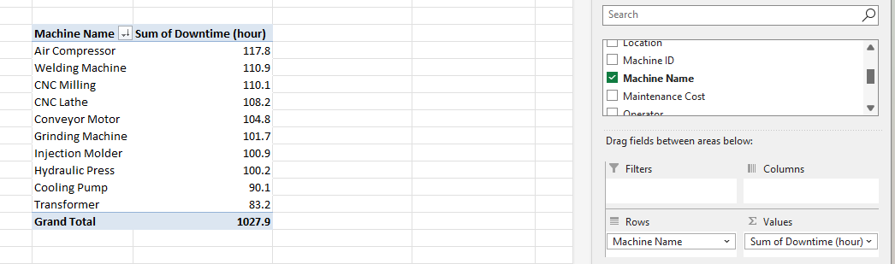

Q4. Maintenance Cost Analysis
Create a Pivot Table showing:
- Total Maintenance Cost by Machine
- Average Maintenance Cost by Department
- Find the machine with highest maintenance cost

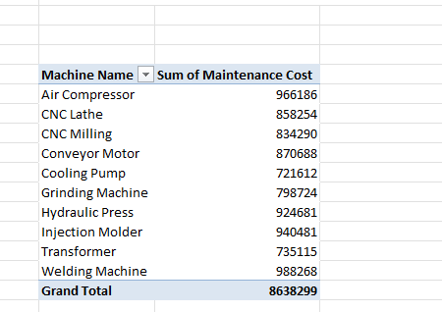
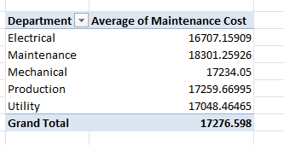

Q5. Efficiency Analysis
Create a Pivot Table showing:
- Average Efficiency by Machine
- Average Efficiency by Department
- Find the Top 5 most efficient machines
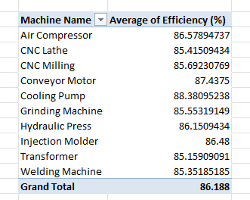

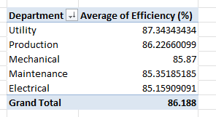

Part B — Date & Time Analysis Using Pivot Table

Q6. Monthly Production Trend
Create a Pivot Table:
- Group Date by Month
- Show total Production for each month
Create a line chart.
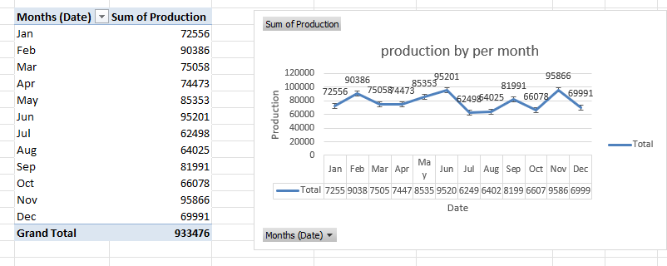

Q7. Monthly Downtime Trend
Create a Pivot Table:
- Month-wise total downtime
Create a column chart.
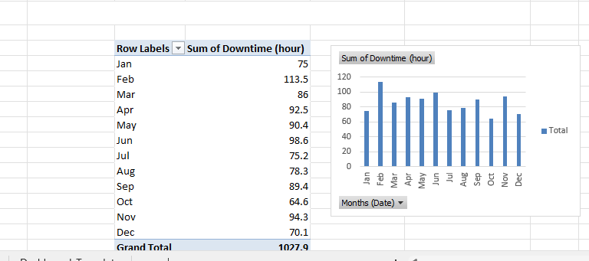

Q8. Monthly Maintenance Cost
Find:
- January maintenance cost
- February maintenance cost
- Highest cost month
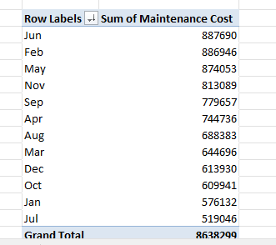

Part C — Interactive Dashboard
Add slicers for:

Q15.
Create slicer for:
- Department
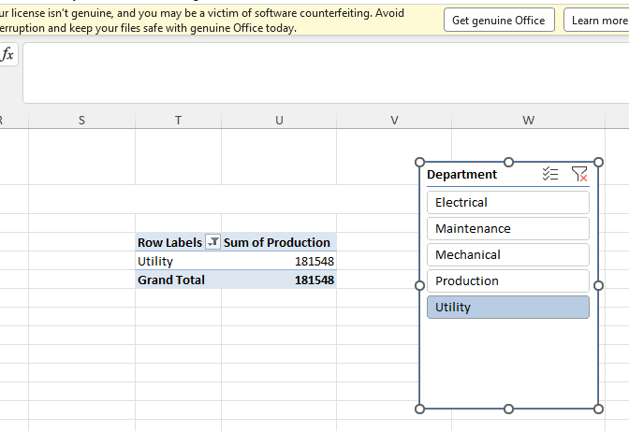

Q16.
Create slicer for:
- Machine Status
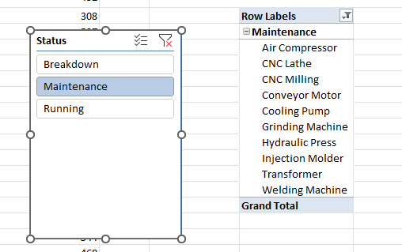

Q17.
Create slicer for:
- Month
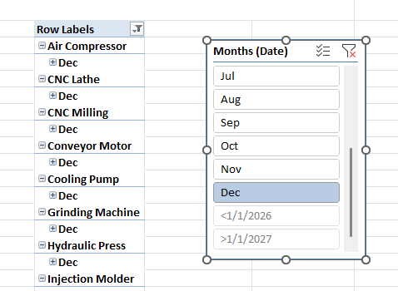

Part D — Machine Ranking

Q18. Best Performing Machine
Find the machine with:
- Highest Efficiency
- Lowest Downtime
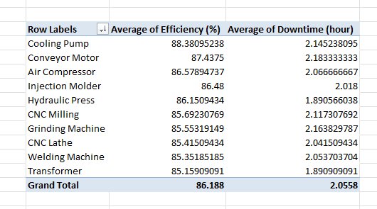

Q19. Worst Performing Machine
Find the machine with:
- Lowest Efficiency
- Highest Downtime
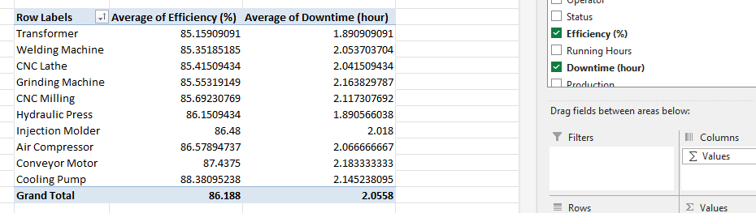

Q20. Top 5 Problematic Machines
Create a table based on:
- Highest downtime
- Highest maintenance cost

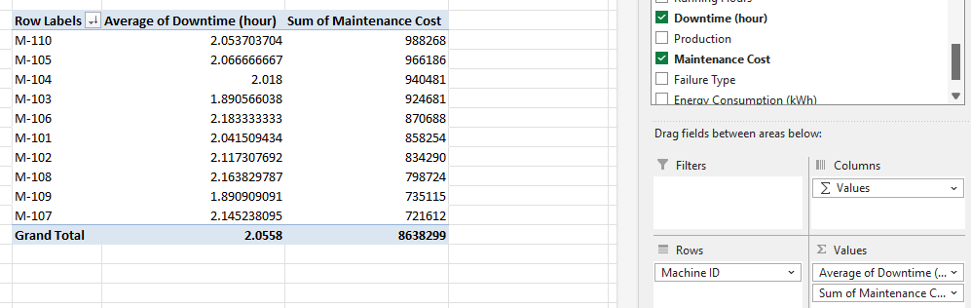

Part E — Conditional Formatting

Q21.
Highlight machines:
Efficiency < 85%
Color:
Red
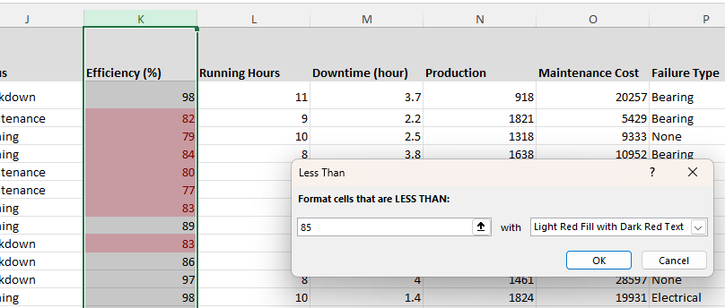

Q22.
Highlight machines:
Downtime > 2 hours
Color:
Orange
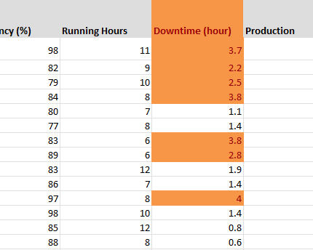

Q23.
Highlight:
Maintenance Cost above average
Color:
Yellow
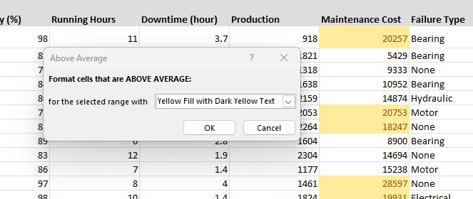

Part F — Advanced Industrial KPIs

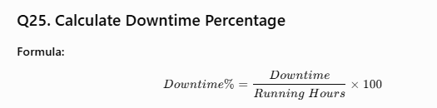
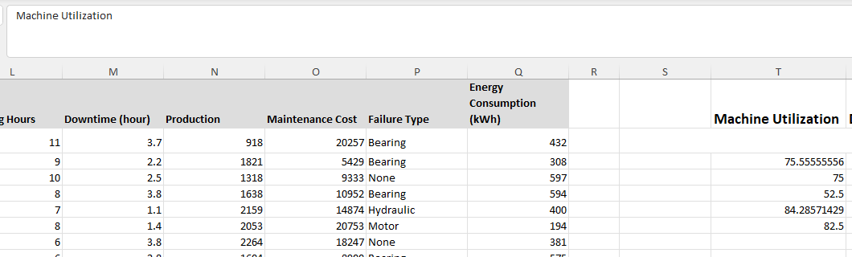

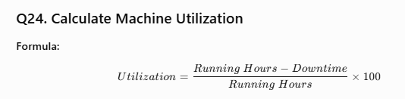

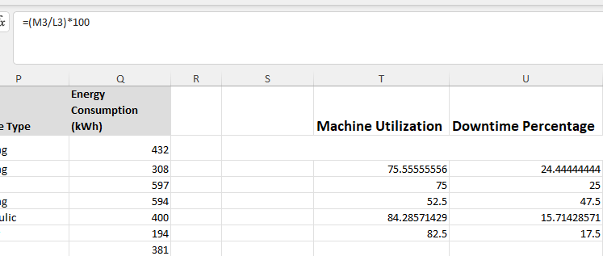
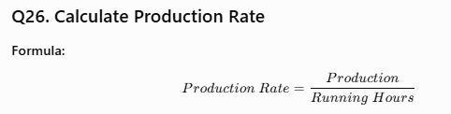
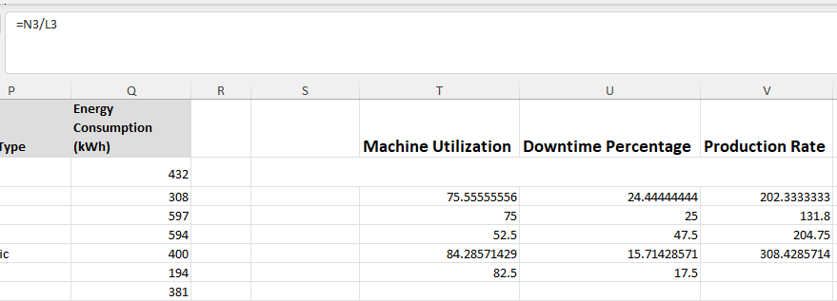

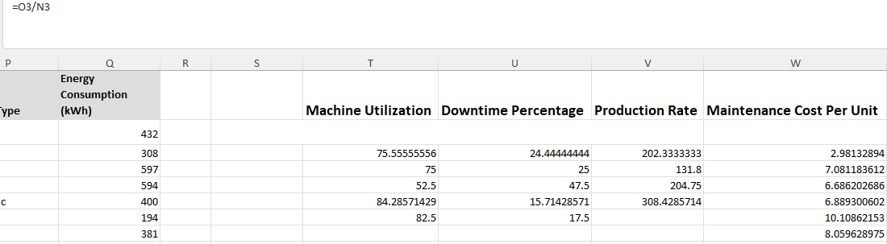

Part G — Advanced Dashboard Features

Q28. Create Top Performing Machines Table
Condition:
- Efficiency ≥ 90%
- Downtime ≤ 1 hour
Show:
- Machine ID
- Machine Name
- Efficiency
- Downtime
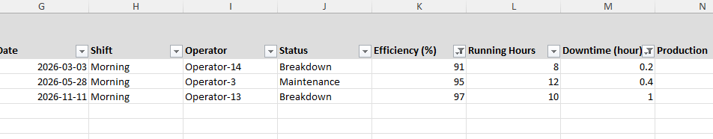

Q29. Create Machines Needing Attention Table
Condition:
- Efficiency < 85%
OR
- Status = Breakdown/Maintenance
Show:
- Machine ID
- Machine Name
- Efficiency
- Status
- Downtime
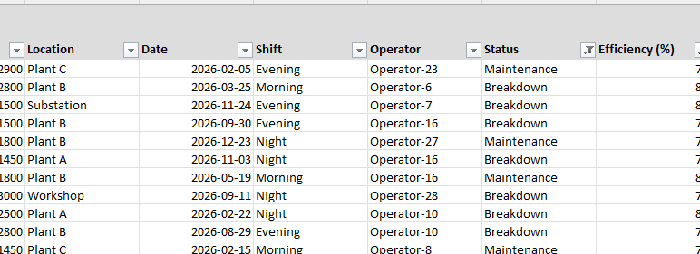

Final GitHub Project
Create:
Industrial Machine Performance Dashboard Using Excel
Your final file should contain:
- Raw Data sheet
- Analysis sheet
- Dashboard sheet
- Pivot Tables
- Pivot Charts
- Slicers
- KPI Cards
- Conditional Formatting
- Final Report
This will be a complete portfolio-level Excel project.

